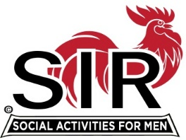

Las Trampas Branch 116
Luncheon Meeting Agenda
Sept 19th, 2022, 10:30 AM

10:30 Check-in
Greeters at the door – Paul Ramacciotti, Alan Pope
Vaccination Check – Kevin Donahue
Treasurer Table – Al Satake
Name Tags Table – Phil Goff
Raffle Table – Ben Bryce

11:25 Five Minute Call
11:30 Call to order; Welcome back to all – Big SIR
Pledge of Allegiance – Fred Schafer
Chaplain – Terry Sherman
Sunshine Report – Matt Arena

11:40 Story Teller – Fred Schafer
11:45 Branch Updates – Fred Wachowicz, Roger Craig
Christmas Party, Dec 14th
Oct Luncheon Meeting

11:45 Salad Served
12:00 Lunch
12:10 Activity Committee Announcements – Alex Lutkus
12:20 Introduce Speaker, SIR Doctor Paul Freitas – Roger Craig
13:05 Speaker Thank You, Little SIR - Roger Craig
13:10 Raffle Drawing – Ben Bryce
Birthday Drawing– Little SIR - Roger Craig
13:20 Sing Happy Birthday – Music - Paul King
Sing God Bless America - Paul King

13:25 Closing Remarks – Big SIR
13:30 Adjourn; Next Meeting, Oct 17th
************************************************

